**Continental Colony**

***Parental Involvement Policy and Plan for Shared Student Success***

**2015-2016 School Year**

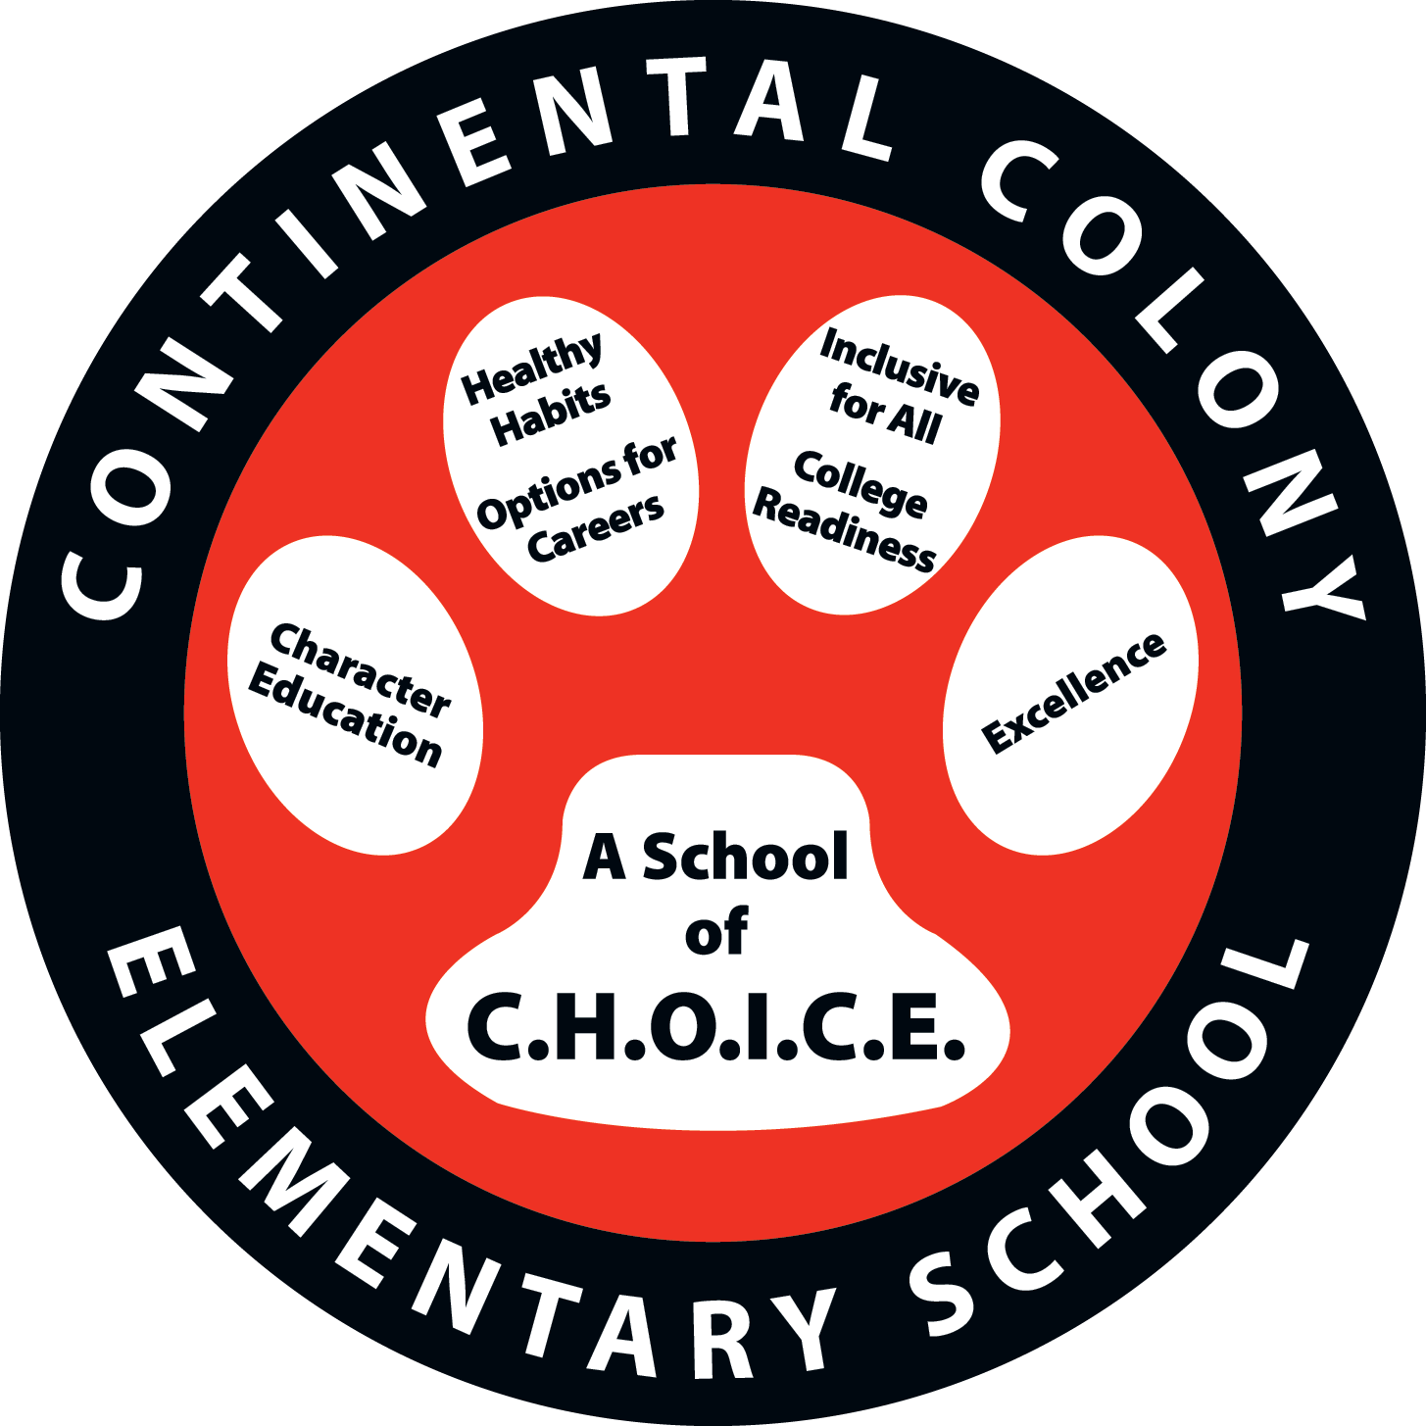

Mr. Frederico L. Rowe, Principal

3181 Hogan Rd, SW

Atlanta, GA 30331

404-802-8000

<http://www.atlanta.k12.ga.us/Domain/457>

*Revised: September 14, 2015*

**What is Title I?**

***Continental Colony*** *is identified as a Title I school as part of the Elementary and Secondary Education Act of 1965 (ESEA). Title I is:*

* *A federally funded program which provides services to schools based on student economic needs.*
* *Designed to support State and local school reform efforts tied to challenging state academic standards to improve teaching and learning for students.*

*All Title I schools must jointly develop with all parents, a written parental involvement policy.*

**School Plan for Shared Student Achievement**

**What is it?**

This is a plan that describes how ***Continental Colony*** will provide opportunities to improve family engagement to support student learning. ***Continental Colony*** values the contributions and involvement of parents to establish an equal partnership for the common goal of improving student achievement. This plan describes the different ways that Centennial Academy will support parent engagement and how parents can help plan and participate in activities and events to promote student learning at school and at home.

**How is it developed?**

***Continental Colony*** invited all parents to attend our School Wide Planning and Budget meeting to review and revise this parental involvement policy, our school-parent compact and the parental involvement budget. Additionally, parent input and comments regarding this plan are welcome during the school year through an online form. The plan is posted on our school Web site for parents to view and submit feedback throughout the year. All parent feedback received during the year will be used to revise the plan for the next school year. We also distribute an annual survey online and by mail to ask parents for their suggestions on the plan and the use of funds for parental involvement. Parents can also give feedback during several parent meetings and activities during the school year.

**Who is it for?**

All students participating in the Title I, Part A program, and their families, are encouraged and invited to fully participate in the opportunities described in this plan. ***Continental Colony*** will provide full opportunity for the participation of parents with limited English, parents with disabilities and parents of migratory children.

**Where is it available?**

The plan is posted to the school Website, emailed to all parents, distributed at the Annual Title I meeting and in the Front Office. Parents can also retrieve a copy in the Parent Resource Center located on the lower level by the Kindergarten Cluster in room 1032.

***2015-2016 District Goal***

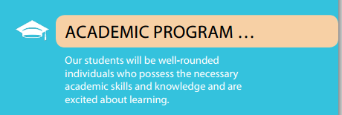

**2015-2016 Continental Colony Goals**

Increase the mathematics proficiency as defined by the internal Computer Adaptive Assessment data for Meeting/Exceeding Standards by 10% percentage points.

The focus for math is: Fact fluency and application of complex mathematical problem-solving in grades K-5.

**School-Parent Compacts**

As part of this plan, ***Continental Colony*** and our families will develop a school-parent compact. It is an agreement that explains how parents, teachers and students work together to make sure all our students reach grade-level standards.

The compacts are reviewed and updated annually based on feedback from parents, students and teachers during the Schoolwide Planning meeting and the School Forum.

Parents and teachers worked diligently to create compacts for the school. A copy of the school-parent compact brochure is distributed to every family to use during the year. This compact goes out in late September.

**Let’s Get Together!**

***Continental Colony*** will host the following events to build the capacity for strong parental involvement to support a partnership among the school, parents, and the community to improve student academic achievement.

***Open House – August 3, 2015***

Meet your child’s teacher and our friendly and helpful school staff for the year.

***Annual Title I Meeting– August 18, 2015***

We invite parents/guardians out to participate in our Annual Title I Meeting to learn about our school’s Title I program.

***Curriculum Night– August 18, 2015***

Parents/guardians meet and greet teacher. See what student will be learning.

***Parental Involvement Policy/School-Parent Compact Meeting – August 22 and 27, 2015***

Parents/guardians you are invited to help review and revise these to important documents. Share your ideas and/or suggestions. Meeting will be held in the Parent Resource Center, Room 1032.

***Parent University: – Monthly (dates will be announced)***

Learn academic strategies to better help your child at home.

***Principal’s Chat Series –1st Friday of Every Monthly***

Participate in a chat with the Mr. Rowe on way to better CCES. Come and share your positive suggestions.

***Parent-Teacher and Student Conferences – October 1, 2015 & February 15, 2016***

Scheduled updates on your child’s progress.

***Math Fluency Workshop – October 16, 2015 & January 29, 2016***

Gain relevant knowledge on math

***Reading Bootcamp Pt. I & II– September 11, 2015 & February 19, 2016***

Gain knowledge about topics relevant to your child’s education.

***Math-o-ween Workshop-October 31, 2015***

Parents and student gain know from using manipulative through game

***Diving into Technology (Math and Reading) November 13, 2015 & March 11, 2016***

Using technology to learn how to help students in the area of math and reading through apps

*Future Events will be posted on the schools website, and announced through take home flyers, email, texts, Facebook, twitter and voice messenger.*

***Parent Resource Center***

Our Parent Resource Center is located on the lower level near the Kindergarten Cluster in room 1032. We have a library of resources for parents/guardians to check out.

Open: Monday-Friday 9:00 am – 2:00 pm.

Please contact Sonya Williams, Parent Liaison, via email [sxwilliams@atlanta.k12.ga.us](mailto:sxwilliams@atlanta.k12.ga.us) or at 404-802-8000 if you have any questions.

**Parental Involvement**

Here at ***Continental Colony*** we believes that parental involvement is the participation of parents/guardians in a regular two-way communication involving student academic learning and other school activities, including ensuring:

* That parents play a role in assisting their child’s learning;
* Parents are encouraged to be actively involved in their child’s education at school and home.
* That parents are full partners in their child’s education and are included in decision-making and on advisory committees to assist in the education of their child.
* The carrying out of other activities as described in this plan.

Continental Colony is committed to helping our parents attend the parental activities listed in this plan.

(404-802-8000

Sonya Williams, Parent Liaison [sxwilliams@atlanta.k12.ga.us](mailto:sxwilliams@atlanta.k12.ga.us)

**Continental Colony is “A school of C.H.O.I.C.E”**

We will take the following measures to promote and support parents as an important foundation of the school in order to strengthen the school and reach our school goals.

We will:

* Ensure that all information related to school and parent programs, meetings, and other activities is published in English and Spanish, posted on the school Web site, and included in the monthly school newsletter for all parents.
* Provide trainings for staff during their planning periods on strategies to improve communication with parents and ideas to increase family engagement. Staff will also share best practices during regularly scheduled faculty meetings.
* Partner with Head Start and Early Reading programs by conducting joint staff meetings for parents and sending school information about parent engagement activities to help prepare parents and their child for kindergarten and improve school transition.
* Share information in English and Spanish on the school blog and in the school newsletter for parents to understand the school’s academic standards and assessments as well as the ways parents can monitor their child’s progress and work with educators.
* Communicate with all families and the community on a regular basis regarding schoolwide events and activities, through phone messages, social media (Facebook, Twitter, bloomz.net) and flyers.
* Work with our parents to develop relevant trainings and helpful presentations to educate our staff on the importance of parental involvement.
* Provide necessary materials and handouts for parents at conferences, meetings, and activities to help parents work with their child to improve their child’s academic achievement.
* Use our Partners in Education and Panther Family Advisory Committee to improve awareness of the activities and events listed in the school parental involvement policy.
* Collect feedback from parents at all events, place input card around the building and post suggestions form on the school website in order to respond to parents’ requests.

**Parent Involvement Standards**

***Continental Colony*** invites **ALL** parents to join the Title I ***Panther Family Advisory Committee (P-FAC)*** to share ideas and ways to involve other parents/guardians to build partnerships with school, families, and the community. The team will meet during the school year, but parents can also submit their ideas or suggestions during all activities and meetings as well as through our parent surveys and website.

If you would like to learn more about the Title I Panther Parent Advisory Committee please contact Parent Liaison, Sonya Williams via email [sxwilliams@atlanta.k12.ga.us](mailto:sxwilliams@atlanta.k12.ga.us)

or by phone 404-802-8022.

**Panther Family Advisory Committee**

The ***Panther Family Advisory Committee (P-FAC)*** at ***Continental Colony Elementary School*** will function on a volunteer basis: 1. to help organize, plan, and review programs and the school. 2. To have an open dialogue and enhance communication between the school and families. 3. To have an opportunity to provide suggestions to the school. ***P-FAC*** will meet to discuss matters that are of interest that directly affect the school and stakeholders. ***P-FAC*** will meet on a **regular basis**. Meeting information will go out by flyer, robo call, text, marquee, Facebook, twitter, bloomz.net, and email. If you are interested and would like to join the ***P-PAC***, contact Mrs. Sonya Williams @404-802-8022 or via email [sxwilliams@atlanta.k12.ga.us](mailto:sxwilliams@atlanta.k12.ga.us).

**P-FAC Members Duties and Responsibilities**

As a ***P-FAC*** member, I will:

* Help jointly develop the Parent Involvement Policy and School-Parent Compact
* Participate in ***P-FAC*** in some, if not all, of meetings/workshops
* Serve as an ambassador for ***Continental Colony*** by sharing information to other stakeholders
* Help serve to strengthen the school, family, and community partnership
* Provide feedback and advice to the school
* And any other duties and responsibilities ***P-FAC*** agrees upon as a group.

**Parent Center Information**

***Continental Colony*** ***Parent Center*** located on the Lower Level in Room 1032.

***Parent Center*** Open ***Monday-Friday***

8:30AM-2:00PM

***Sonya Williams, Parent Liaison***

404-802-8022

[sxwilliams@atlanta.k12.ga.us](mailto:sxwilliams@atlanta.k12.ga.us)